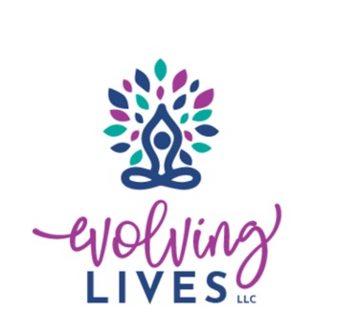
Alice Whitlow Scholarship Fund Application
Please complete the application in its entirety. Incomplete applications will not be considered for scholarship awards. The deadline for this application to be received is May 31st. No exceptions!

Please send completed application to: Attn: Scholarship Committee

Mail: Email:
1990 Louisville Rd Ste 107 admin@evolvinglivesllc.com
Bowling Green, KY 42101

Purpose
To provide an academic book scholarship to graduating seniors who will be attending a post-secondary educational institution and/or trade school in the state of Kentucky.
- DEADLINE for scholarship applications is May 31st. (no exceptions)
- Scholarship Amount: $250 per recipient
- There will be two scholarship recipients
- Refer to criteria below for eligibility requirements.
- Refer to the application process below for a list of the supporting documents needed. Incomplete applications will not be considered.
- If any questions do not apply to you in this application, please put N/A in the space.
- Type or print legibly. Illegible applications will be returned to you unprocessed.
- The recipient will be notified by June 15th.
- If you have any questions about the application, please contact the Scholarship Committee at info@evolvinglivesllc.com
- Scholarship funds will only be awarded (ONCE) to the student’s college/university OR trade school account upon your application being reviewed by the committee and selected as a scholarship recipient.

Criteria
- Applicant must be a resident of Kentucky
- Applicant must be a graduating high school senior or GED equivalent.
- Applicant GPA must be 2.5 or higher.
- Applicant must be enrolled as a full-time student at a college /university carrying at least 12 credit hours or must be enrolled full-time at a trade school in the state of Kentucky.
- Applicant must have an acceptance letter from a college/university and/or trade school.

Application Process
Applicant must submit the following items:
- Completed application form (if handwritten, please print legibly)
- Letter of application addressed to the Scholarship Committee with a brief explanation of career goals



Alice Whitlow Scholarship Fund Application

Please complete the application in its entirety. Incomplete applications will not be considered for scholarship awards. The deadline for this application to be received is May 31st. No exceptions!

Please type or print your answers. If application is illegible, it will be returned to you.

First Name Last Name
Address
City
State
Zip/Postal Code
Primary Phone
Date of Birth (Month, Day, Year)
Name of parent(s) and/or legal guardian(s)
Address of parent(s) or legal guardian(s)
Current High School
Number of years attended
Please list the school you will be attending and which semester

If decided, what specialty/major and/or minor do you plan to study as you continue your education?

What are your educational and professional goals and objectives?

List your academic honors, awards, and membership activities while in high school:

List your community service activities, hobbies, outside interests, and extracurricular activities:

The following items must be attached to this application for the application to qualify to be reviewed by the scholarship committee. Any incomplete applications will not be processed (No exceptions.)
Two (2) recommendation letters: Return these completed forms by mail and/or email to the address or email listed above.
Proof of college acceptance: A letter of college and/or trade school acceptance is required for receipt of funds.
Most recent official high school transcript: Photocopies of your transcript are not acceptable.

Personal Essay: In 1-2 pages, describe yourself and how have you made a positive difference in your community, school, family, etc.?

STATEMENT OF ACCURACY
I hereby affirm that all the above stated information provided by me is true and correct to the best of my knowledge. I also consent that my picture may be taken and used for any purpose deemed necessary to promote The Alice Whitlow Scholarship Fund.
I hereby understand that if chosen as a scholarship recipient, according to the Evolving Lives Scholarship Policy, I must provide evidence of enrollment/registration at the postsecondary institution or trade school of my choice before scholarship funds can be awarded.

Signature of scholarship applicant:
Date:

